**Cosy Airconditioners**

***User* *Guide***

|  |  |  |
| --- | --- | --- |
| Supervisor | Tooba Khawar | |
| Batch. | 2109C2 | |
| Group. | B | |
| Serial No. | Enrollment Number | Student Name |
| 1. | Student1338821 | SOHAIL . |
| 2. | Student1336549 | MUHAMMAD SHAHARYAR . |
| 3. | Student1336558 | MUHAMMAD IRTEQA KHAN |
| 4. | Student1336555 | SYED YOUNUS ALI |

|  |
| --- |
| ***User Guide*** |

|  |
| --- |
| 1.Home (0.Home.html) |

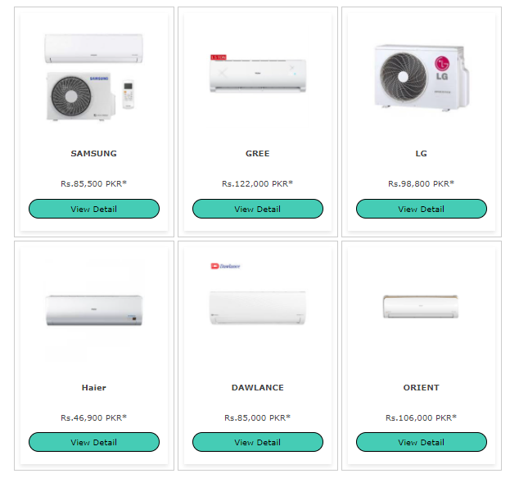

Figure 1:Home page to Cosy Airconditioners

* Used to select the Button displayed on the website:

|  |
| --- |
| 2. Layout Top |



Figure2:Upper Frame Interface

2.1.1 Home Section

When clicking the home button, and the system will load the page to select

The home(0.Home.html)

2.1.2 Contact Section

When you click the Contact button, the system will display the Contact Form.

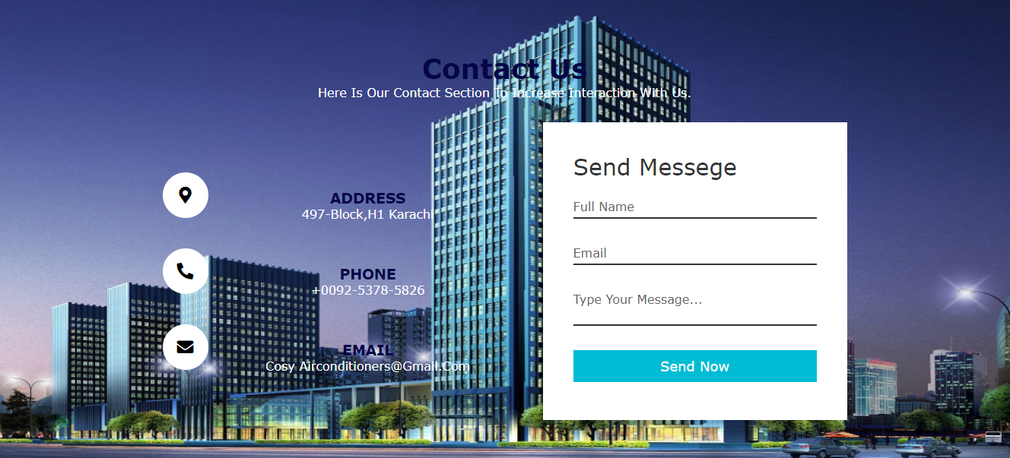

Figure 3:Contact Form

Email:

* Start with a letter or number.
* End with a letter and number.
* Dots, hyphens, and underscores are allowed for email names but must comply with the following requirements:
* Do not use in the start and end position.
* Its previous and next position must be a alphanumeric character.
* The position immediately after the @ character can be a sequence of alphabetic characters or alphanumeric characters followed by one or more phrases that start with a dot and followed by a string of up to 4 letter characters. Its previous and next position must be a alphanumeric character.

Name:

* Start with a letter
* End with a letter

Type Your Messege:

* Start with a letter or number.
* End with a letter and number.

When clicking the Send Now button, the system Will check the data in the fields in turn and the error message dialog box will appear if an error is detected.

* All Fields is Required! Please Fill The All Fields!

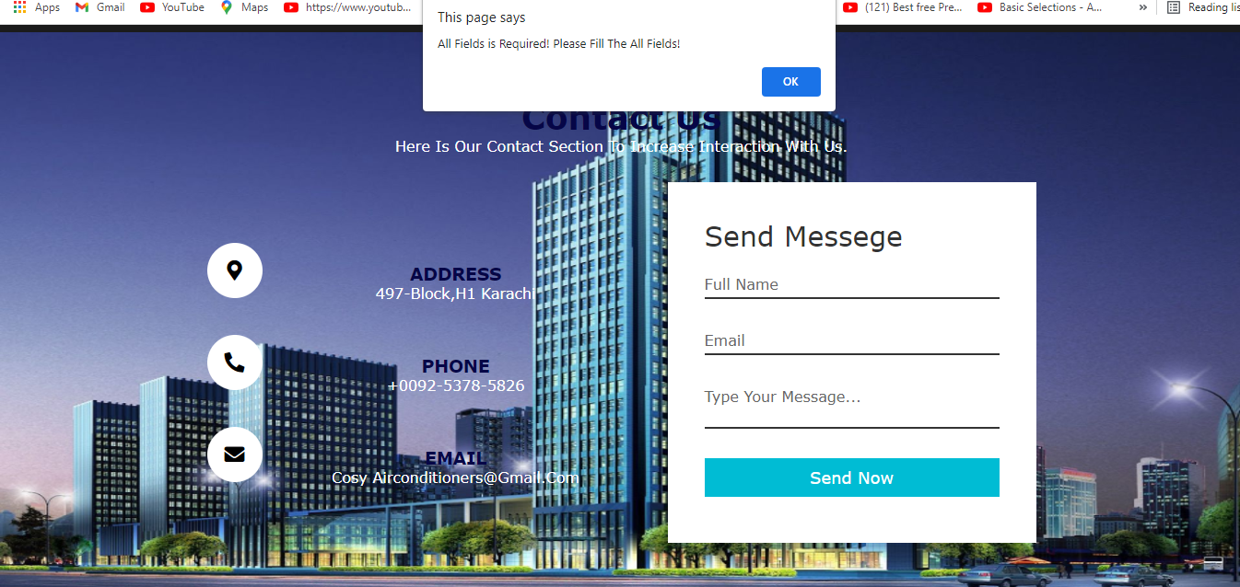

Figure 4: All Fields is Required

* Email is Required!

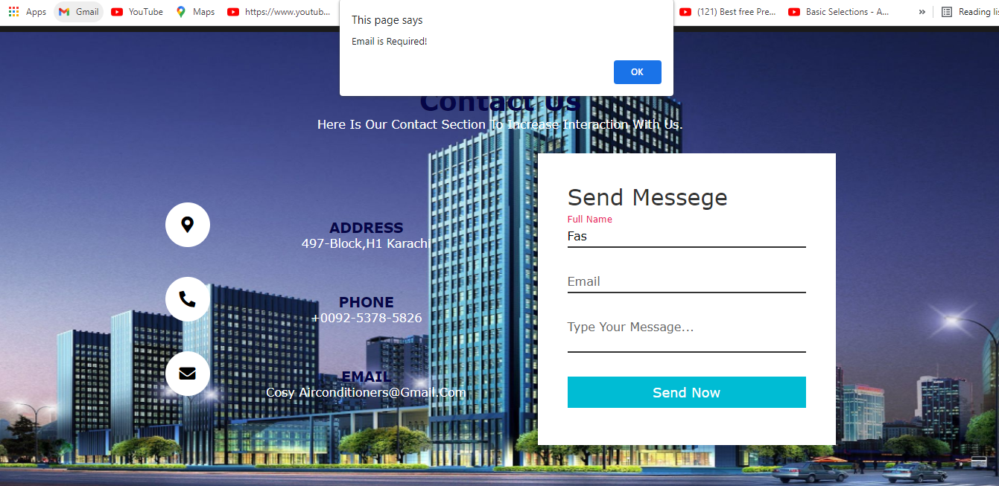

Figure 5: Email is Required

* Text Area is Required!

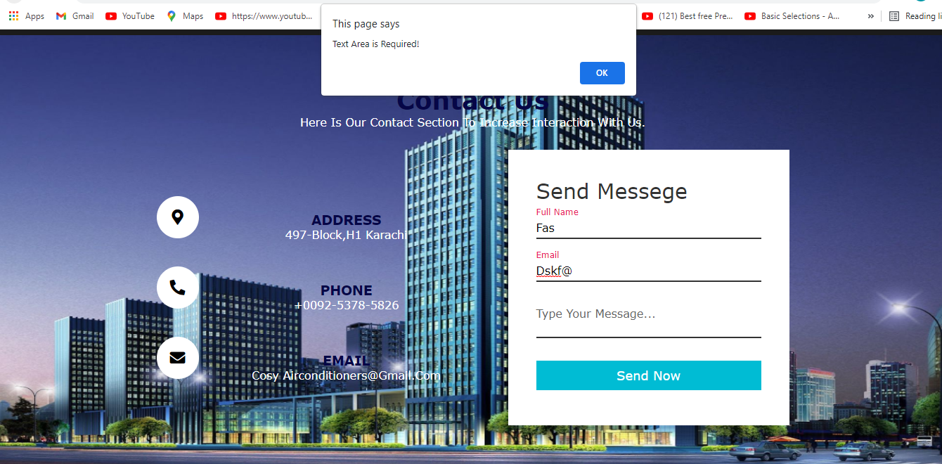

Figure 6: Text Area is Required

* Login Successfully!

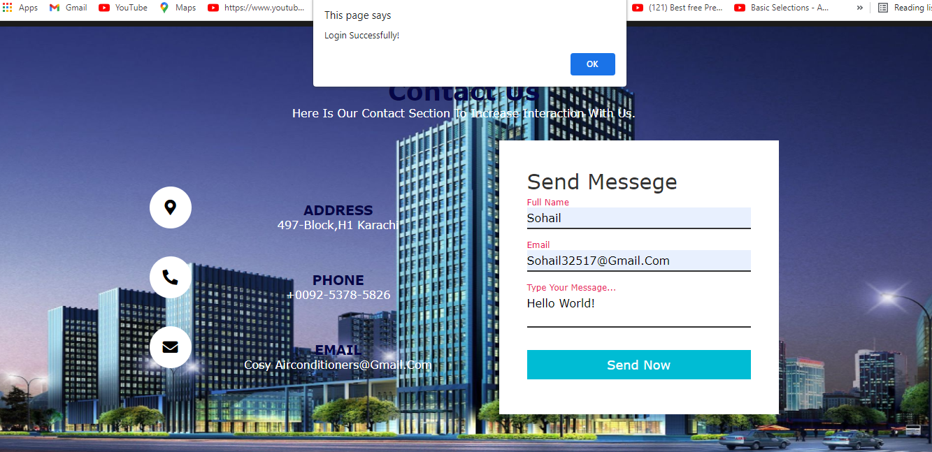

Figure 7: Login Successfully

When the Contact button is clicked, the Contact page interface is displayed (see description on the Contact page).

2.2 Menu Bar



Figure 8:Menu Bar

Used to load the remaining pages. The following is a list of those pages:

* Home Page (1.Home.html)
* Brand Hover(#)
* Smasung Page(2.Samsung.html)
* Gree Page(3.Gree.html)
* Lg Page(4.Lg.html)
* Haier Page(5.Haier.html)
* Dawlance Page(6.Dawlance.html)
* Orient Page(7.Orient.html)
* Contact page(8.Contact.html)

Drop-down menu bar: The Brand tab of the Menu can be removed and contains submenus that lead to subpages. You can access these pages (main page or subpage) by Mouse Hover on its tab.

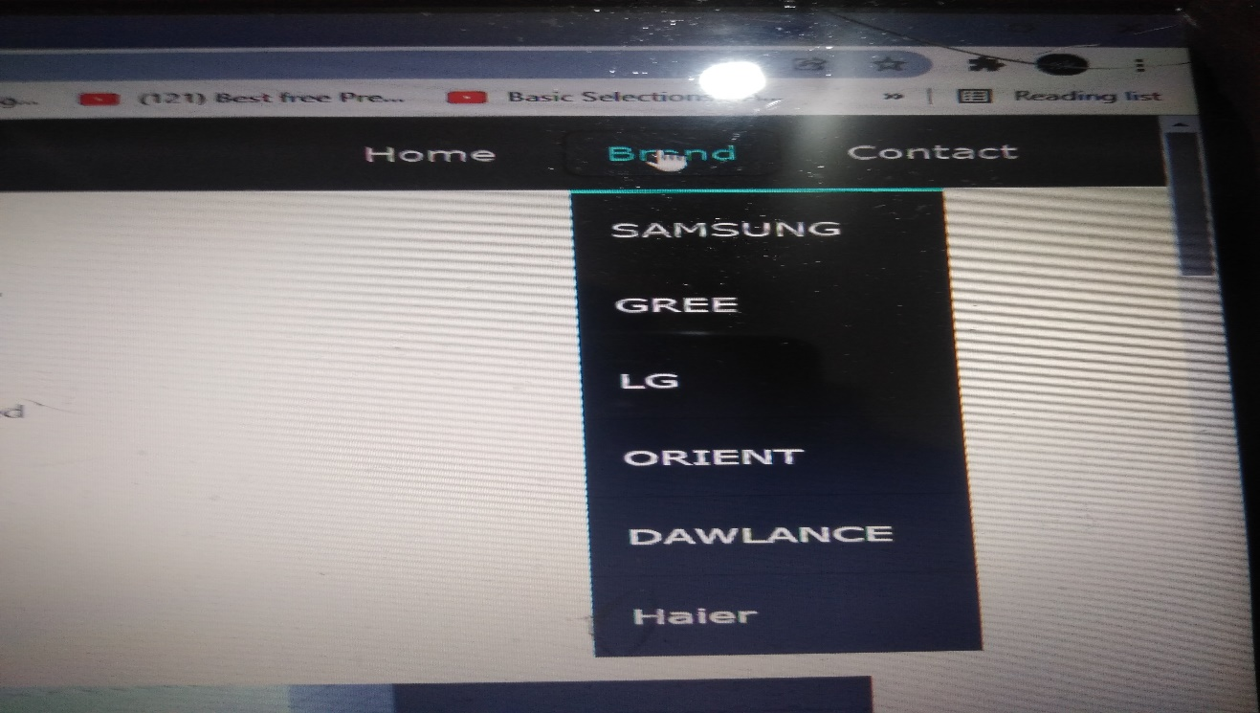

Figure 9:Dropdown Menu Brands

3.Layout Bottom

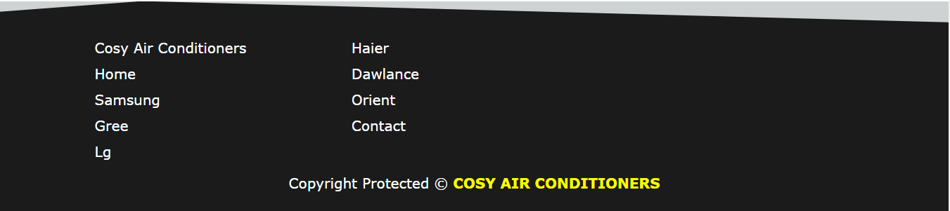

Figure 10:Layout Bottom

4. Home Page (1.Home.html)

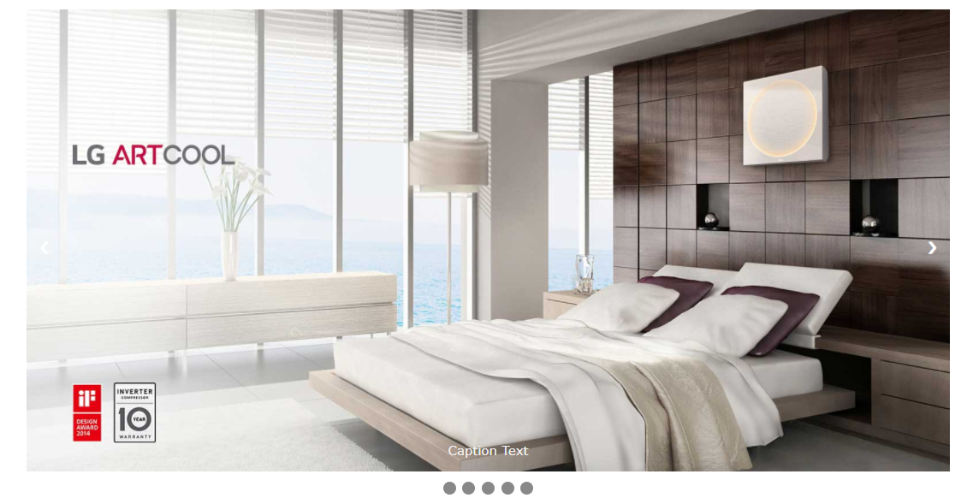

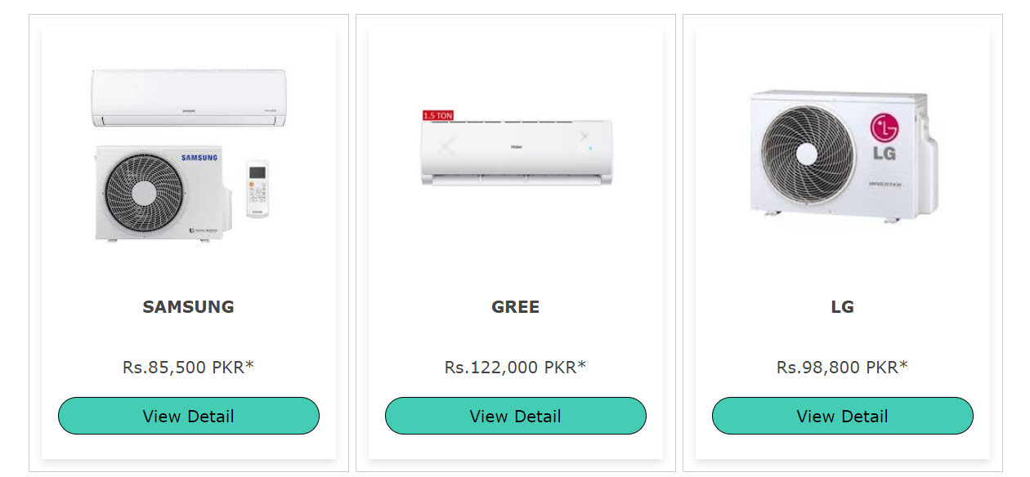

The interface of the Home page is show as Figure: Home Page Products.

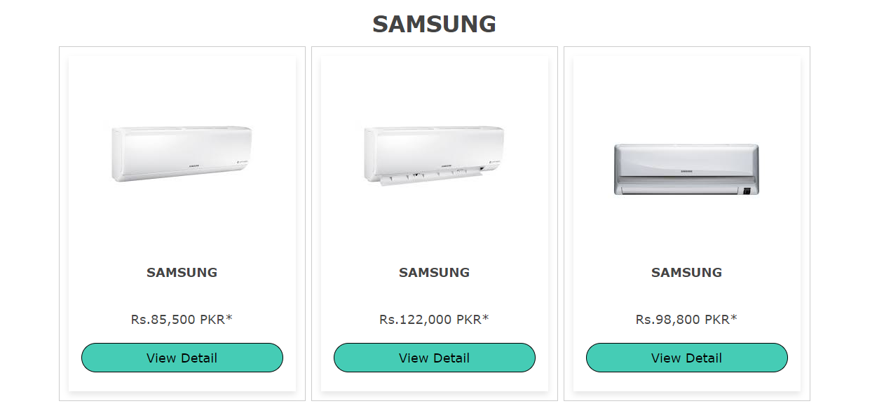

The interface of the Smasung page is show as Figure: Samsung Products.

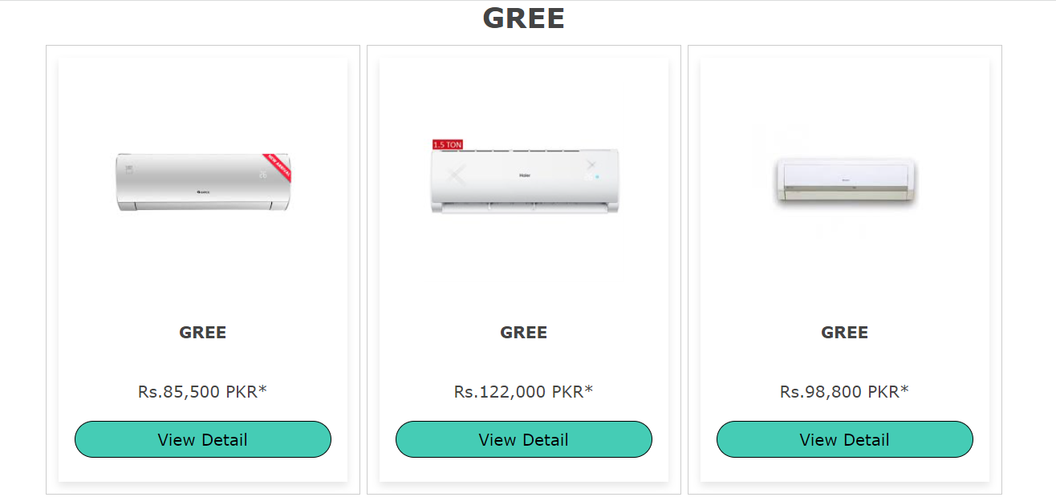

The interface of the Gree page is show as Figure: Gree Products.

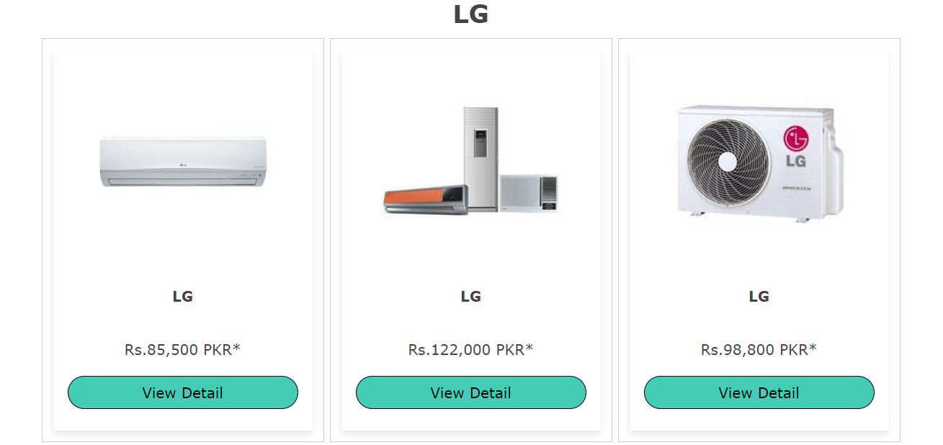

The interface of the Lg page is show as Figure: Lg Products.

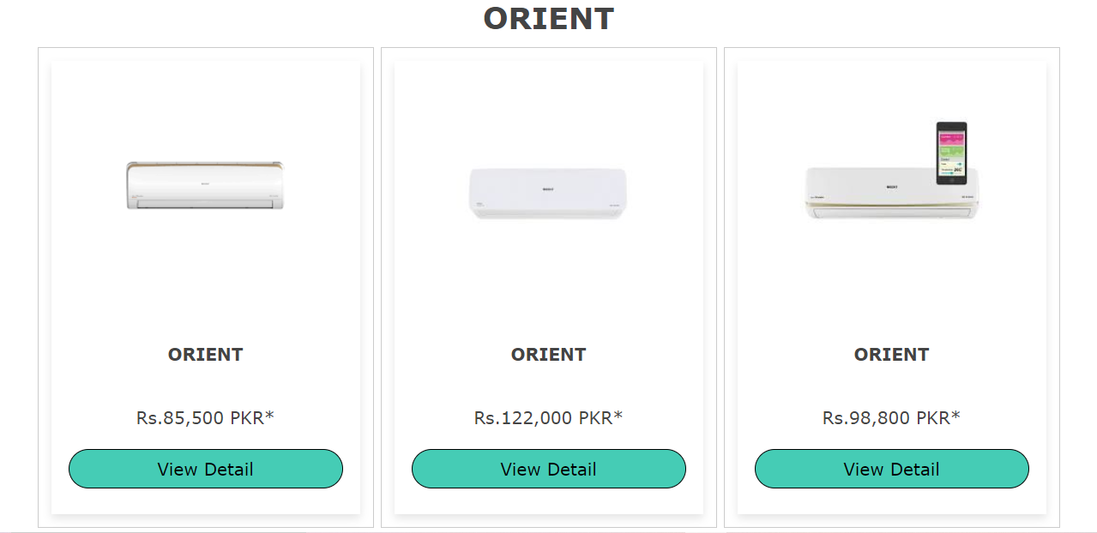

The interface of the Orient page is show as Figure: Orient Products.

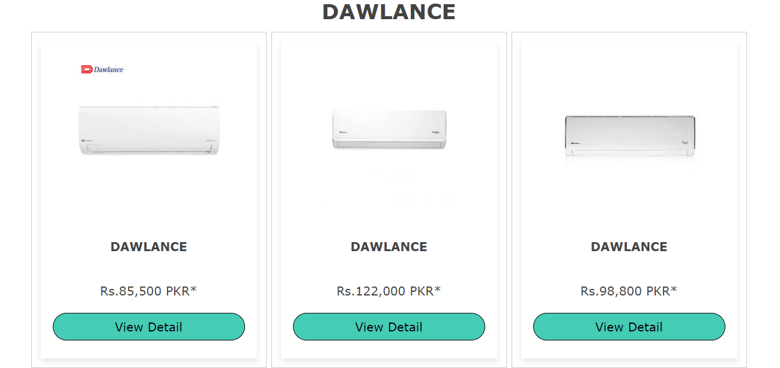

The interface of the Dawlance page is show as Figure: Dawlance Products.

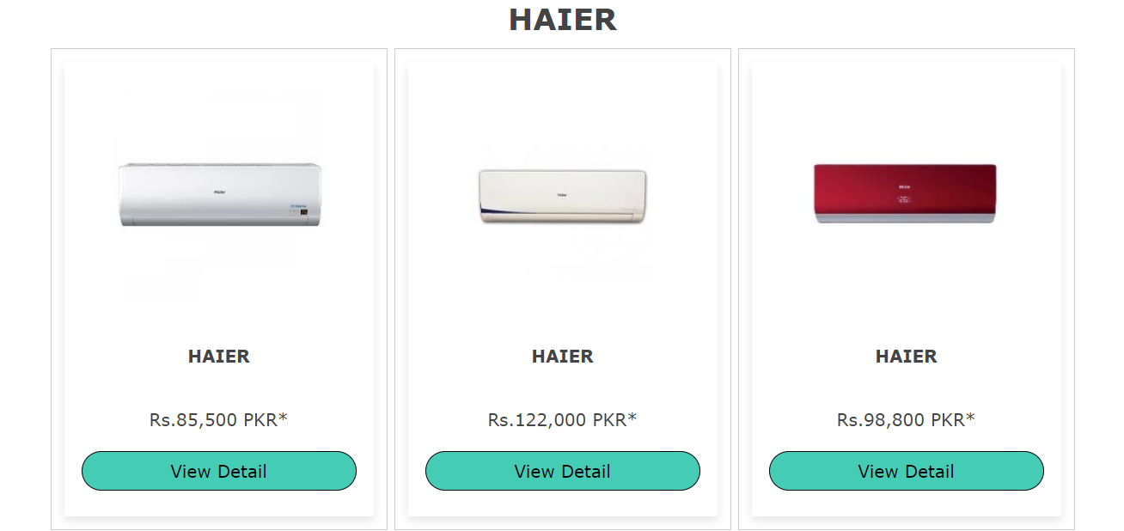

The interface of the Haier page is show as Figure: Haier Products.